Mathematics | We will be having an in-depth hands-on focus on the following topics:  - Place Value – numbers to 10,000, rounding to nearest 10 and 100, find 1, 10 and 100 more or less, negative numbers and roman numerals.  - Addition and Subtraction- add and subtract up to 4 digit numbers, estimating and checking strategies.  - Measurement – mm, m and km and finding perimeter.  - Multiplication and Division – multiply and divide by 10 and 100. Times table focus looking at patterns and strategies for 3, 6, 7 and 9 times table.  - Problem solving and reasoning tasks throughout all of the above topics.
English | Theme: Dragons and Discovery  Class Focus Texts – How to train your dragon by Cressida Cowell  Drama, Speaking and Listening  - Use spoken language to develop understanding through imagining and exploring ideas.  - Select and use appropriate registers for effective communication.  - Build an imaginative picture of a fantasy world.  - Explore these through role play and through writing in role.  Reading  - Increase familiarity with a range of books.  - Identify themes and conventions.  - Prepare play scripts to read aloud.  - Show understanding through intonation, tone, volume and action.  - Discuss words and phrases that capture readers’ interest and imagination.  - Draw inferences about characters’ feelings, thoughts, emotions and actions.  Writing  - Plan writing by discussing writing similar to that which they are planning to write, learning from its structure, vocabulary and grammar.  - Draft and write by composing and rehearsing sentences orally.  - In narrative create settings, characters and plot.  - Develop creative and imaginative writing by adopting, creating and sustaining a range of roles.  - Write informative texts including instructions and non-chronological reports.  Punctuation and Grammar  - Identify word class e.g. nouns, verbs, adverbs, adjectives and determiners.  - Use fronted adverbials and expanded noun phrases.  - Use apostrophes for possession including plurals.
Science | Living things and Habitats  - Recognise that living things can be grouped in a variety of ways.  - Explore and use classification keys.  - Recognise that environments can change and that this can sometimes pose dangers to living things.  Electricity  - Construct a simple series electrical circuit.  - Identifying and naming basic parts, including cells, wires, bulbs, switches and buzzers.  - Identify whether or not a lamp will light in a simple series circuit and recognise some common conductors and insulators.
Humanities  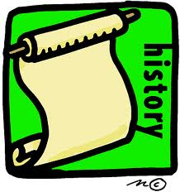 | History - Anglo-Saxons  - An Anglo-Saxon timeline  - Invasion  - The legend of Beowulf  - Saxon Society  - Home Life and Farming  Geography - Rivers  - Importance of water and its impact on rivers  - Features of a river  - Physical effect of rivers  - Examination of impact of human activity and causes of pollution  RE – Buddhism  - Buddhists beliefs and lifestyles  - Buddhist temples  - The Tipitaka and Buddhist symbols
Computing | - Internet safety  - Word processing and desk-top publishing
Art   | Seurat and Pointillism  - Find out who Georges Seurat was and explore his style of art.  - Explore how to create art in the style of Pointillism.  - Explore how he used colours in his artwork and created effects and shading.  - Explore the work of other Pointillist painters.  - Create own piece of Pointillist artwork.
French | Café Conundrum  - To order drinks and snacks in a café.  - To give simple opinions about foods.  - To say and order multiples of 10 to 100.
PSHE | ‘It’s our World’ and ‘Say No’  - Understanding rules and laws, environmental awareness and sustainability issues.  - Risk taking, legal and illegal drugs, effects and risks of smoking and drinking alcohol, Anti-Bullying.
PE  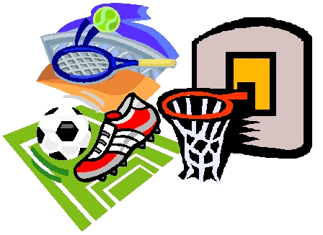 | - Football - passing, receiving, stopping/controlling, dribbling, shooting, rules, small sided games  - Netball - passing, catching, footwork, shooting, marking, dodging, rules, small sided games  - Hockey - passing, receiving, stopping, dribbling, tackling, shooting, marking, small sided games.  - Dance – following a sequence of moves, creating own moves, responding to stimuli such as music, pictures or themes, working cooperatively in groups to create group pieces.  - Yoga – following poses and moves, linking moves together, developing focus, concentration and reflection.  - Gymnastics – rolling, balancing, movement, linking moves together to create short sequences. Use of equipment.
Music   | - Exploring Rhythm Group drumming including West African drum patterns and Samba music.  - Sing a range of songs and complete rhythm activities.

